Padification srs

Date: 2017-06-08

Version: 0.8.3

McKenzie College SWTS2102

1. Revision History

|  |  |  |  |
| --- | --- | --- | --- |
| Date | Author | Version | Revision Notes |
| 2017-06-06 | William Gale | 0.1 | Heading layout for document. |
| 2017-06-06 | Elie Godbout | 0.2 | Added Sections 2 and 3 being; Conformance and Normative references. |
| 2017-06-06 | Zachary Blue | 0.3 | Added Scope and Definitions, Abbreviations and Acronyms. |
| 2017-06-07 | William Gale | 0.4 | Integrated Player Concept into Section 5.1, Updated Revision History Layout, and Title Page. |
| 2017-06-07 | Elie Godbout | 0.5 | Integrated the Game Overview Concept in section 5.1, Updated revision history, Title page, Table of contents and Added a List of Figures. |
| 2017-06-07 | Kyle Gunton | 0.6 | Integrated section 5.1.3 Dungeons Overview Concept in section 5.1. Updated TOC and List of Figures. |
| 2017-06-07 | Zachary Blue | 0.7 | Integrated the Mailbox Overview Concept in section 5.1, Updated Revision history, Title page, Table of Contents, and List of Figures. |
| 2017-06-07 | Ryan Breau | 0.8 | Integrated the Friend Overview Concept in section 5.1, updated Revision History, Table of Contents, and List of Figures. |
| 2017-06-07 | Elie Godbout | 0.8.1 | Updates to section 5.1.1 (Game overview) Android device requirements updated to 4.0 and higher, egg machine section now explains what types of in-game currency are required to operate the specific types off egg machines. |
| 2017-06-07 | William Gale | 0.8.2 | Updated section 5.1.2 (Player Overview) Improved Definition of Rank, Removed Balloons from figure, Added descriptive location in definitions. |
| 2017-06-07 | Ryan Breau | 0.8.3 | Updated section 5.1.5 (Friends): Improved explanations, changed figures. Integrated section 5.1.6 (Game Currency). |

1. Table of Contents

[I. Revision History 2](#_Toc484678389)

[II. Table of Contents 3](#_Toc484678390)

[III. List of Figures 4](#_Toc484678391)

[1 Scope 5](#_Toc484678392)

[2 Conformance 5](#_Toc484678393)

[2.1 Intended usage 5](#_Toc484678394)

[2.2 Conformance to Processes 5](#_Toc484678395)

[2.3 Conformance to information item content 5](#_Toc484678396)

[3 Normative References 5](#_Toc484678397)

[4 Terms, Definitions, and Abbreviated Terms 6](#_Toc484678398)

[4.1 Terms and Definitions 6](#_Toc484678399)

[4.2 Acronyms and Abbreviations 7](#_Toc484678400)

[5 Concepts 8](#_Toc484678401)

[5.1 Introduction 8](#_Toc484678402)

[5.1.1 Game overview 8](#_Toc484678403)

[5.1.2 Player 11](#_Toc484678404)

[5.1.3 Dungeons 12](#_Toc484678405)

[5.1.4 Mail 14](#_Toc484678406)

[5.1.5 Friends 17](#_Toc484678407)

[5.1.6 Game Currency 21](#_Toc484678408)

[5.2 Requirements Fundamentals 23](#_Toc484678409)

[5.3 Practical Considerations 23](#_Toc484678410)

[5.4 Requirement Information Items 23](#_Toc484678411)

[6 Processes 23](#_Toc484678412)

[6.1 Requirements Processes 23](#_Toc484678413)

[6.2 Stakeholder Requirements Definition Process 23](#_Toc484678414)

[6.3 Requirements Analysis Process 23](#_Toc484678415)

[6.4 Requirements Engineering Activities in Other Technical Process 23](#_Toc484678416)

[6.5 Requirements Management 23](#_Toc484678417)

[7 Information Items 23](#_Toc484678418)

[8 Guidelines for Information Items 23](#_Toc484678419)

[9 Information Item Content 23](#_Toc484678420)

1. List of Figures

[Figure 1: Player information 8](file:///C:\Git\PADification\Docs\SRS\Padification%20SRS.docx#_Toc484678368)

[Figure 2: Player ID search 8](file:///C:\Git\PADification\Docs\SRS\Padification%20SRS.docx#_Toc484678369)

[Figure 3: Main menu bar 9](file:///C:\Git\PADification\Docs\SRS\Padification%20SRS.docx#_Toc484678370)

[Figure 4: Monster box 9](file:///C:\Git\PADification\Docs\SRS\Padification%20SRS.docx#_Toc484678371)

[Figure 5: Player information Displayed in Information Banner 11](file:///C:\Git\PADification\Docs\SRS\Padification%20SRS.docx#_Toc484678372)

[Figure 6: Player Name Change Menu 11](file:///C:\Git\PADification\Docs\SRS\Padification%20SRS.docx#_Toc484678373)

[Figure 7 Dungeons Menu 12](file:///C:\Git\PADification\Docs\SRS\Padification%20SRS.docx#_Toc484678374)

[Figure 8 Mailbox 14](file:///C:\Git\PADification\Docs\SRS\Padification%20SRS.docx#_Toc484678375)

[Figure 9 Piece of mail 15](file:///C:\Git\PADification\Docs\SRS\Padification%20SRS.docx#_Toc484678376)

[Figure 10 Dungeon Mail 15](file:///C:\Git\PADification\Docs\SRS\Padification%20SRS.docx#_Toc484678377)

[Figure 11 Mail Sorting 16](file:///C:\Git\PADification\Docs\SRS\Padification%20SRS.docx#_Toc484678378)

[Figure 12 Best Friend 17](file:///C:\Git\PADification\Docs\SRS\Padification%20SRS.docx#_Toc484678379)

[Figure 13 Mail Expiry 17](file:///C:\Git\PADification\Docs\SRS\Padification%20SRS.docx#_Toc484678380)

[Figure 14 Select a Helper Screen 18](file:///C:\Git\PADification\Docs\SRS\Padification%20SRS.docx#_Toc484678381)

[Figure 15 Team Indication on Helpers 19](file:///C:\Git\PADification\Docs\SRS\Padification%20SRS.docx#_Toc484678382)

[Figure 16 Friend List Screen 19](file:///C:\Git\PADification\Docs\SRS\Padification%20SRS.docx#_Toc484678383)

[Figure 17 Friend Options, Favorited 20](file:///C:\Git\PADification\Docs\SRS\Padification%20SRS.docx#_Toc484678384)

[Figure 18 Friend Options, Not Favorited 20](file:///C:\Git\PADification\Docs\SRS\Padification%20SRS.docx#_Toc484678385)

[Figure 19 Coins and Magic Stones 21](file:///C:\Git\PADification\Docs\SRS\Padification%20SRS.docx#_Toc484678386)

[Figure 20 Monster Points 21](file:///C:\Git\PADification\Docs\SRS\Padification%20SRS.docx#_Toc484678387)

[Figure 21 Pal Points 21](file:///C:\Git\PADification\Docs\SRS\Padification%20SRS.docx#_Toc484678388)

# Scope

Our project PADification will be designed and produced through the following processes: evolving a monster, beating a dungeon, leveling up a monster, selling a monster, and more. Through those processes we will produce a database that contains all the information pertaining to monsters found within the North American version of Gungho’s Puzzle and Dragons mobile videogame. Using that database, we will create a program for the purpose of logging and maintaining a user’s input monsters as well as allow users to search for monsters and simulate team builds. PADification will also allow users to add a wishlist for monsters that they either need or would like to collect in the future.

# Conformance

## Intended usage

The intention of conformance for this SRS document is to help stakeholders understand where the data and information the group has gathered come from and under what format, scope and decree they will follow.

## Conformance to Processes

* The PADification final product aims simulate processes found in the Puzzles and dragons mobile video-game developed by Gungho online entertainment Inc. The main process is as follows:
  + Creation, updates and deletion of teams
    - Leader monster
    - Sub monsters
    - Team name
    - Badge equipped
* The idea behind this is to allow players of puzzles and dragons from around the world to share the teams as well as monsters they own to other players. Something that puzzles and dragons does not permit at the current time.

## Conformance to information item content

* The PADification final product gathers all its information from the puzzles and dragons mobile video-game developed by Gungho online entertainment Inc. as well as from third party website: <http://puzzledragonx.com/com>
* If information found within puzzledragonsx.com should ever prove unreliable, unsure and/or faulty, it is required to have the issue resolved by identifying it within puzzles and dragons.
* Information regarding instances of player information and instances of specific monsters are found within puzzles and dragons by way of the player’s account information.

# Normative References

ISO/IEC/IEEE 29148-2011 SRS International Standard Document

<https://webcache.googleusercontent.com/search?q=cache:OQfOP0Z_vMQJ:https://edisciplinas.usp.br/pluginfile.php/1077344/mod_folder/content/0/iso-iec-ieee-29148-2011.pdf%3Fforcedownload%3D1+&cd=3&hl=en&ct=clnk&gl=ca>

Puzzle and Dragons X

<http://www.puzzledragonx.com/>

“Puzzle and Dragons” game

<https://itunes.apple.com/ca/app/puzzle-dragons-english/id563474464?mt=8>

<https://play.google.com/store/apps/details?id=jp.gungho.padEN&hl=en>

<http://www.gunghoonline.com/games/puzzle-dragons/>

# Terms, Definitions, and Abbreviated Terms

## Terms and Definitions

* + (Plus) stats – Bonus stats applied to HP, ATK, and RCV. Up to 99 + stats can be granted to each stat for a monster for a total of 297. A bonus of +# times 10 is granted to HP, +# times 5 for ATK, and +# times 3 for RCV.
* Active Skill – An modifier belonging to monsters that can be used in dungeons to modify the board, the player’s team or the enemies.
* Assist Monsters – Monsters can be assigned to other monsters. The assisted monster gains the active skill of the assisting monster as well as a possible stat boost while the assisting monster can no longer be brought into dungeons or sold. Not all monsters can be assists.
* Attack – A monster’s statistic that determines the base amount of damage a monster can deal.
* Attribute – A property of a monster that determines the type of damage a monster will deal. A monster can currently have up to two (minimum of one) of five attributes consisting of Fire, Water, Wood, Light, and Dark.
* Awoken Skill – A passive modifier granted to a monster.
* Awoken Skills – A passive modifier a monster may have. All monsters with the same Monster ID have the same Awoken Skills. A monster may have zero to nine of them.
* Database - A structured set of data held in a computer, especially one that is accessible in various ways.
* Dungeon – A section within PAD that allows the user to obtain experience, coins, magic stones, and monsters.
* Egg machine – A feature that allows a user to use magic stones or pal points to procure a random monster from a pool of monsters.
* Evolution - Monsters can evolve/devolve into other monsters when certain conditions are met.
* Health Points – A monster’s statistic that determines how much damage a monster can take before a player dies.
* Latent Awoken Skills - A type of awoken skill that you assign to a monster.
* Latent skills – A passive modifier that can be assigned to monsters through power-up/fusion. Up to a max of 6 can be added to a single monster.
* Leader Skill - An in-dungeon modifier granted to the player based on the leader monster. Not all monsters have one.
* Magic stones – A in-game currency within that can be used to restoring stamina, buying eggs from the egg machine, and allowing the user to continue a dungeon upon death (where applicable). Purchasable with real money.
* Mail System – An in-game communications system through which players can communicate with other players and admin. Monsters and currency are able to be obtained through the mail system.
* Monster – Characters that can be obtained within the game through dungeons, mail, and egg machines.
* Monster Assist – A monster assigned to another monster to offer a second active skill and slight stat boost.
* Monster Experience – An indicator of a monster’s current progression towards it’s maximum potential.
* Monster ID – All unique integer identifier assigned to each monster.
* Monster Level – A statistic of a monster that acts as a modifier based on a monster’s experience.
* Monster Name - All monsters have a name that are unique (if only by case).
* Monster Types - Monsters have 1-3 types. There are currently 12 different types a monster may have.
* Pal points – An in-game currency collected from helping friends in dungeons, using friends’ monsters in dungeons, and logging in each day that is used to purchase pulls from the Pal Egg machine.
* Puzzle and Dragons – A game involving monster collection and team creation required to defeat more difficult Dungeons.
* Rank – a player grading system that determines the amount of stamina, friends, features the Player can have.
* Rarity - An indicator of how common or uncommon a monster is.
* Recovery – A monster’s statistic that determines the base amount of health a monster will heal for the team.
* Stamina – An integer value that determines a player’s access to a dungeon. Entering a dungeon will take a specified amount of stamina from the player’s current stamina count. Stamina recharges over time up or upon ranking up, to the maximum amount a player can hold. The amount a player can hold is based on rank.
* Type – A classification of a monster. A monster can currently have up to three (minimum of one) of (currently) twelve types.

## Acronyms and Abbreviations

* PAD – Puzzles and Dragons
* HP – Health Points
* ATK – Attack
* RCV – Recovery
* RDBMS – Remote Database Management service
* DB – Database
* NA – North America

# Concepts

## Introduction

### Game overview

Puzzles and Dragons is a video-game developed by Gungho entertainment Inc. for mobile platforms. The objective of this Puzzles and Dragons is to collect monsters by way of various methods, create teams with these monsters in order to complete dungeons which grants the player with various rewards such as new monsters and in-game currency. Clearing dungeons also push a player’s account by way of experience points. This effectively increases a player’s ability to access more advanced parts of the video-game. The rewards obtained can be used to enhance their monsters and be used to accomplish other tasks.

Compatible mobile devices:

* Apple IOS 6.0 and higher
* Android 4.0 and higher
* Kindle
  + Fire (2nd generation)
  + Kindle HP
  + Kindle Fire HDX
* Puzzles and Dragons requires the player to create an account in order to use the application. Once the account is created or when signing in, A player’s account will contain the player’s personal information and account information such as currency, rank, monsters, cleared dungeons, etc.
  + 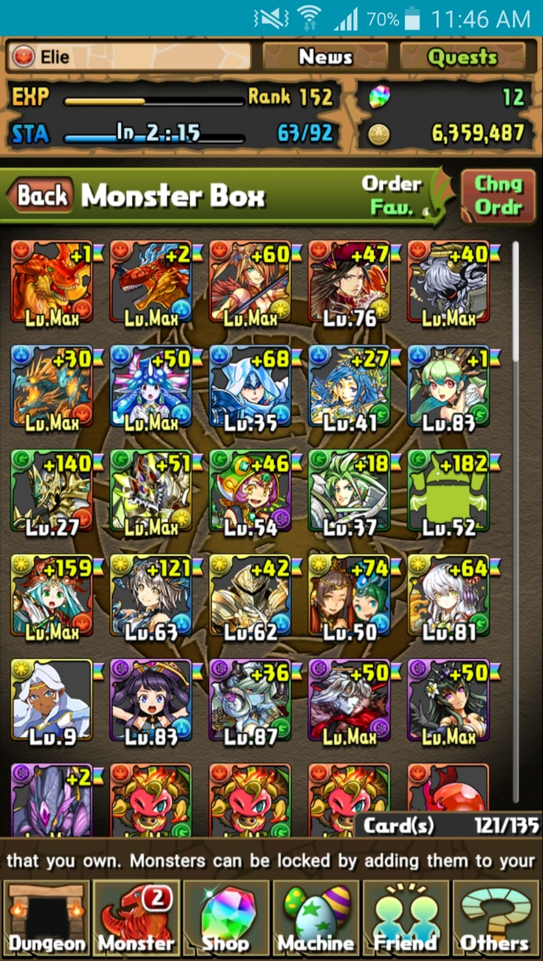Rank

Figure : Player information

* + Current & Max Stamina
  + 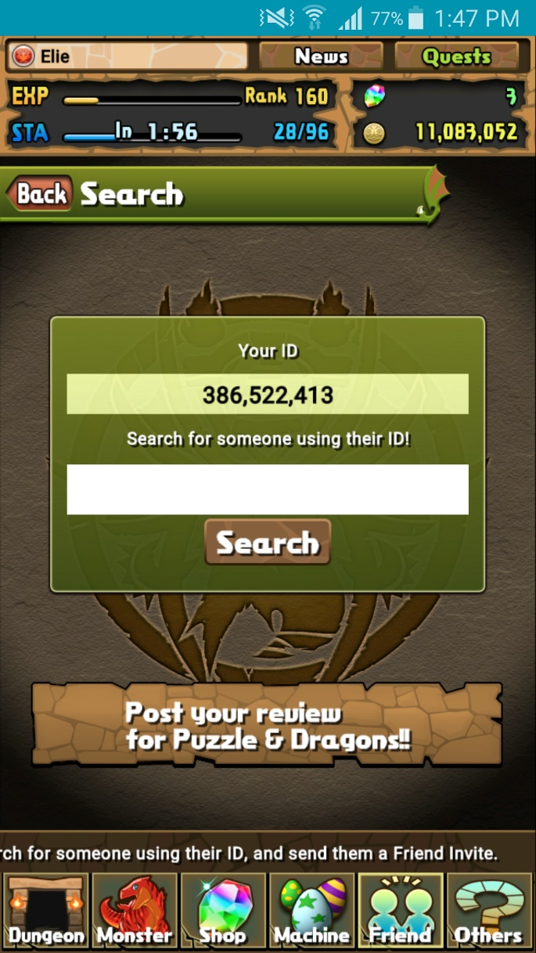Currency

Figure : Player ID search

* + - Magic stones
    - Coins
    - Pal points
    - Monster points
  + Attribute
  + Player ID
* 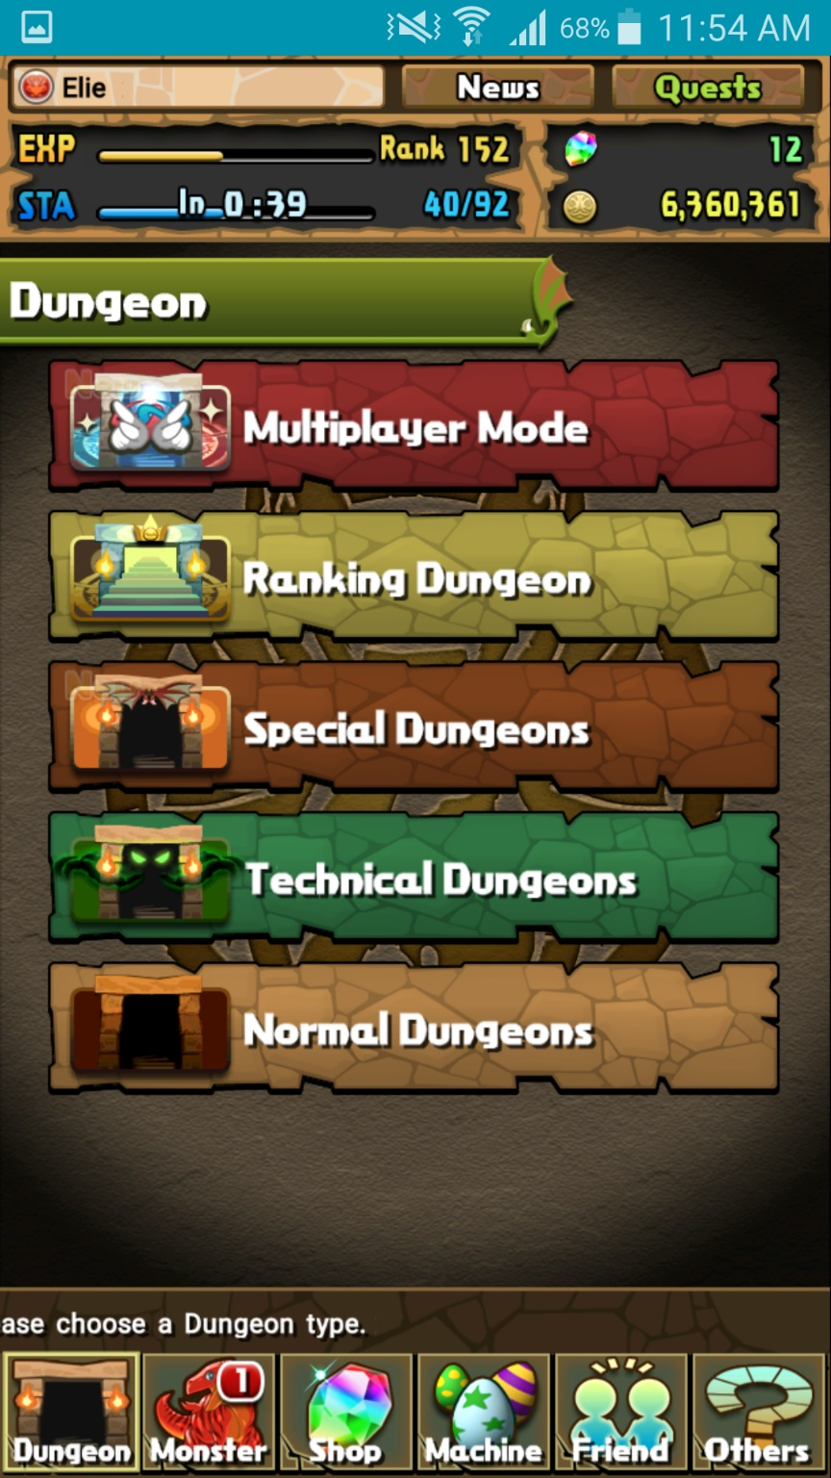Puzzles and Dragons contains an ever-present menu system located at the bottom of the game window. (except when in gameplay)

Figure : Main menu bar

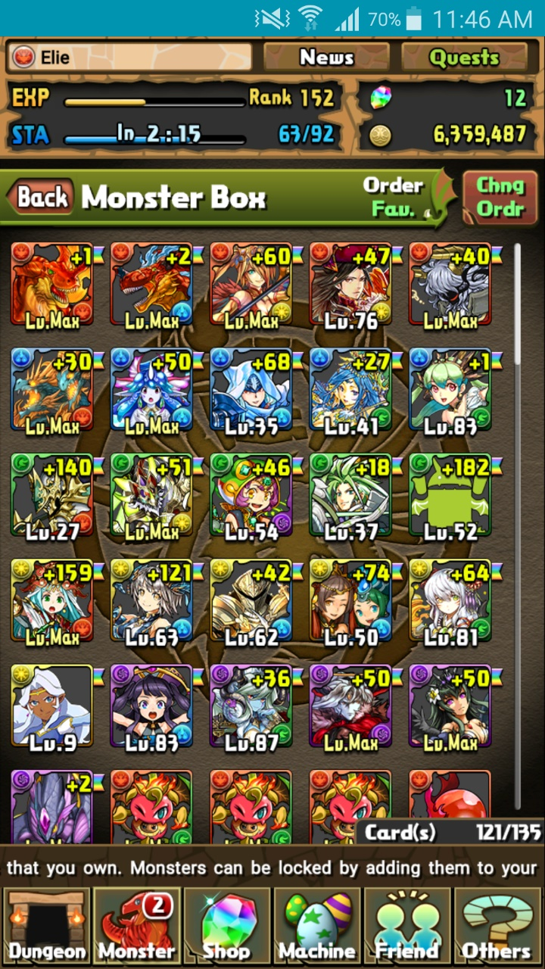

Figure : Monster box

* From the Monster option on the main menu, a player has access to a list of monsters they’ve acquired while playing known as the monster box. Within this section, a player can select a number of additional options such as:
  + Viewing their monster collection via Monster Box
  + Sell Monsters
  + Manage Assists
  + Evolve or Ultimate-evolve monsters
  + Enhance monsters via level-up Fusion
  + Edit teams for use in dungeons
* From the Dungeons option, players can access the main gameplay of Puzzles and Dragons known as dungeons. There exist many types of dungeons:
  + Normal
  + Technical
  + Special
  + Multiplayer
  + Ranking
  + Coin dungeons
* From the Shop option, players have access to shops in Puzzles and Dragons. Here, a player can perform microtransactions to buy an in-game currency known as Magic Stones. Further more, you can spend these Magic Stones to purchase certain items such as monsters. A player can also spend coins for other items.
  + Magic stone shop (microtransactions)
  + Monster shop
  + Coin dungeons
  + Refill stamina
  + Expand monster box
  + Expand friend list capacity
* From the machine option, a player has access to a lottery style monster generator known in-game as egg machines. These allow players to spend in-game currency to obtain randomly chosen monsters. Depending on the specific egg machine, players will have to spend either Pal Points or Magic stones to use them.
  + Pal egg machine (Pal Points required)
  + Rare egg machine (Magic stones required)
  + Special event egg machine (Magic stones required)
    - **Note:** This option is not always available
* From the Friend option, players may interact with other players by sending invitations to others and register them as friends by sharing player IDs. Players can then choose to send messages to their friends and best friends.
  + View registered friends via Friend List
  + Search for players and view your player ID in ID search
  + View messages and notifications in Mail / Invites
  + Send Mail is used to send messages specifically to registered friends
* From the Others option, players have access to a wide range of options concerning the functions of the application, links to external sources, services about the game, information about Gungho, options to change certain settings, etc.
  + Links
  + Monster Book
  + Options
  + Help
  + User info
  + Support
  + Device change
  + Terms of service etc.
  + Data Installation
  + Screen Display Settings
  + Return to Title Screen
* Found on the top right corner, players have access to quests. These offer rewards to players once specific conditions are met. Each quest is classified within categories and state the specific request needed to obtain the reward associated to a given quest.
  + Degree of difficulty
  + Descended
  + Maniacs
* On the top corner of the window, next to the quests option, players have access to a news section to view the latest information on the daily activities of Puzzles and Dragons and/or any changes and updates done to the application. All these are composed by Gungho.

### Player

The Representation of the entity playing Puzzles and Dragons, it holds all information related to the specific user, it consists of the following Elements:

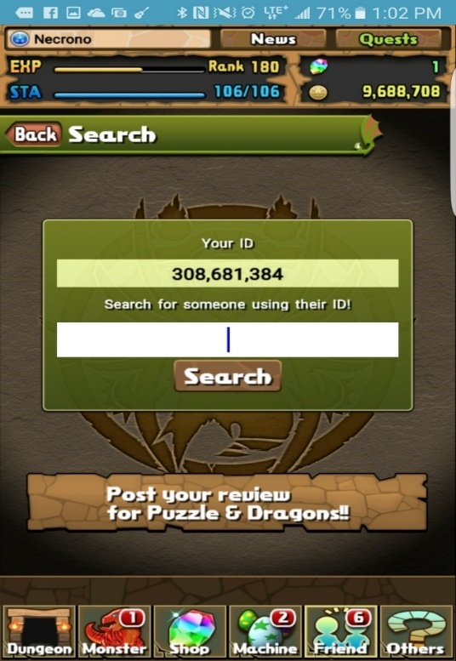

Figure : Player information Displayed in Information Banner

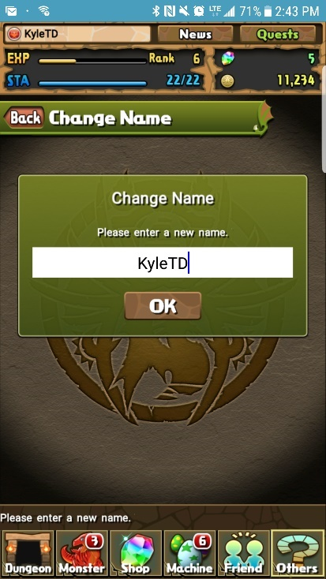

Figure : Player Name Change Menu

* Player ID - A Unique 9 Digit identifier of the Player, Used for account identification, and migration / recovery. Located at the top left corner of start screen.
* Name - Chosen by the Player; Displayed to other Players, but not used for account identification as it is not unique and changeable at any time. Displayed in top left corner of the information Banner.
* Experience - Obtained through completion of dungeons. It is used to determine a player’s Rank. Displayed in the top left dark area of the information Banner as EXP.
* Rank - An integer value determined by your current exp. Gaining Rank restores your Stamina, as well as granting an increase to Max Team Cost, Max Stamina, and Max Friends at predetermined Ranks. Displayed to the Right of the EXP bar.
* Stamina - An integer value based on level that regenerates 1 every 3 mins, fills on Rank up or with a magic stone Purchase, spent when entering Dungeons. Displayed in the top left Dark area in the information banner as STA, it is the left numeric value on the right side of the blue stamina bar.
* Max Stamina - This is the maximum amount of Stamina a Player can store. It is displayed on the right side of the Stamina value.
* Coins - An in-Game Currency, Used in power-up fusion, and Dungeon Purchases. It is displayed in the bottom of the right Dark area of the information Banner.
* Magic Stones - An in-Game currency gained from first time dungeon completion, real money purchase, promotional events. Used for Rare Egg Machine, Restoring Stamina, fully heal team on lose, increasing capacity, and increasing max friends past 50. Displayed in the top of the right Dark area of the information Banner.
* Monster points - An in-Game currency used to purchase monsters. Value is viewable at the Monster Point Shop.
* Pal Points - An in-Game currency earned from using a Helper during Dungeons. Value is Viewable by Selecting the Pal Point Machine.
* Quests - A set of Goals to complete which grant various Rewards, In the form of Dungeons, Badges, Monsters and Currency.
* Collection - The Players collection of currently owned Monsters.
* Monster Book - A book of all monster the Player has seen and captured.
* Starting Attribute - Selected by starting monster picked, Places icon next to name. Determines player’s time group as well as their ID. Located to the Left of players Name
* Teams - Groups of 1-5 monsters picked from the players Monster Collection, used to play dungeons.
* Friends - A collection of players friended by the Player, Allows use of friend leaders as helpers.

### C:\Users\kyleg\AppData\Local\Microsoft\Windows\INetCache\Content.Word\Dungeons_Menu_Screenshot.pngDungeons

Figure Dungeons Menu

Dungeons are a feature within the Puzzles and Dragons video game in which players use teams of monsters to fight other monsters. A dungeon is comprised of one or more floors, each of which contains one or more monsters that must be defeated to proceed to the next floor. Upon defeating all the monsters within a dungeon, the user will obtain rewards.

**Rewards:**

These rewards include player experience, coins, magic stones, pal points, and monsters that you defeated within the dungeon. All of these rewards are available after each time a dungeon is cleared except magic stones which are only available for first time clears. Not all monsters are obtainable even if they are found within a dungeon and the monsters that are obtainable from a dungeon may be a different evolution than the one defeated within the dungeon.

Clearing certain dungeons will result in a reward that will be sent to in-game mail system.

**Dungeon and Sub-Dungeons:**

Dungeons consist of sub-dungeon(s) that can be cleared to obtain magic stones.

* Clearing all brown colored sub-dungeons within a dungeon will grant a magic stone.
* Clearing all non-brown colored sub-dungeons within a dungeon will grant a magic stone.
* Clearing all sub-dungeons within a dungeon will grant that dungeon a cleared status.

**Categories:**

There are a number of different categories under which a dungeon may fall. These include, but are not limited to:

* Normal Dungeons
  + A series of dungeon in which dungeons are cleared in a specific order. When one dungeon is cleared the next one will be unlocked for a player to play. In certain cases, clearing a dungeon will unlock multiple dungeons or no dungeons.
* Multiplayer Dungeons
  + Available in 2-player mode and 3-player mode.
  + Dungeons share cleared status with dungeons from other categories.
  + Dungeons from other categories such as Special Dungeons (except reward dungeons) and technical dungeon are available in 2-player mode.
  + Technical Dungeons
    - Clearing a dungeon in multiplayer will unlock it for a player and mark the dungeon as cleared if it has not yet been unlocked or cleared for that player.
* Special Dungeons
  + Daily Dungeons
  + One-Time Dungeons (only available before it is cleared for the first time)
  + Reward Dungeons (rewards are only given for first time clears)
  + Event Dungeons
* Ranking Dungeons
* Technical Dungeons
* Challenge Mode Dungeons: Normal and technical dungeons may be cleared in Challenge mode for an extra stone after they have been cleared once.
* Coin Dungeons
  + Coin Dungeons are available for a limited time in the multiplayer section after purchase in shop.
  + Coin dungeons with the same names as other dungeons do not share their clear status.

**Dungeon Requirements:**

All dungeons have specific requirements. Each dungeon has a stamina cost a player must pay to enter as well as the possibility to have one or more of a number of modifiers. These modifiers include but are not limited to:

* Board size modifiers
* Orb types appearance modifiers
* No duplicate monsters (except helper)
* Assists invalid
* Awoken Skills Invalid
* Leader Skills Invalid
* All Attributes Required
* Type Enhanced (1.5x monster stat multiplier)
* Attribute Enhanced (1.5x monster stat multiplier)
* No Continues
* Fixed Team
* Set Orb Movement Time
* No Skyfall orbs

**In Dungeon Content:**

* You are able to enter a dungeon with one of your teams as long as the dungeon requirements are met.
* You are able to bring in a helper monster (one of your friend’s monsters) to assist you in the dungeon.
* Your helper monster’s leader skill will be active (unless dungeon modifiers specify otherwise).
* Continues: You are able to continue playing a dungeon for the price of a magic stone if you lose (unless otherwise specified).
* 4 seconds base move time + Awoken/Latent Awoken Skill bonuses (unless otherwise specified).

### Mail

**What is Mail?**

Mail in Puzzle and Dragons comes in many different types with many different options on sorting it. Mail may come in the following types: Quest Rewards, Event Gifts, Friend Gifts, Friend Messages, Friend Invites, Dungeon Rewards, and Best Friend Invites. Mail can also contain a variety of things which are the following: Coins, Pal Points, Monster Points, Magic Stones, and Monsters.

**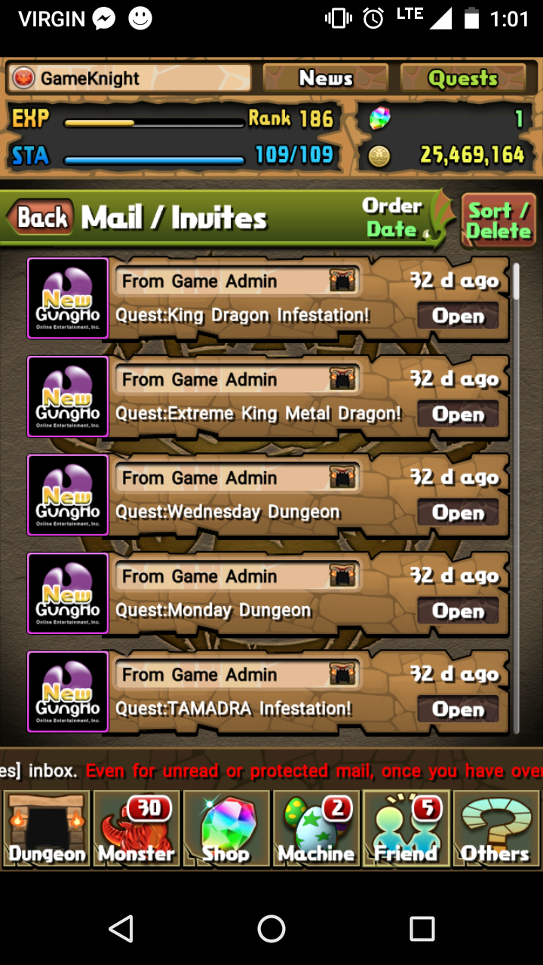Mail Screen**

This is a screen similar to what a player would see when they open their mailbox

Figure Mailbox

**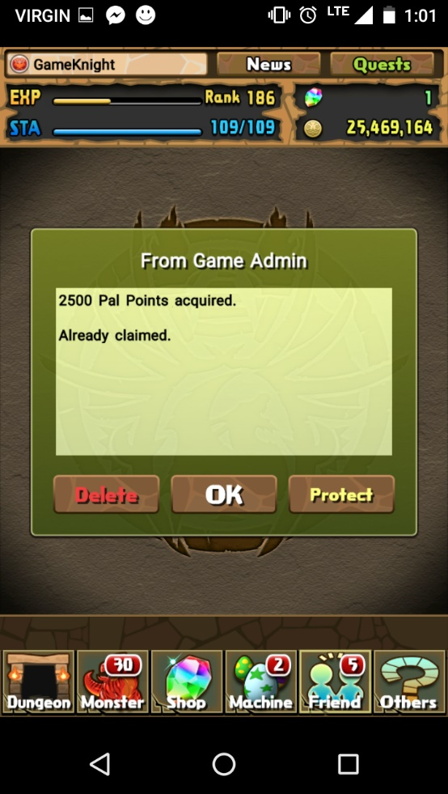Mail**

This is the screen displayed upon opening a piece of mail.

Figure Piece of mail

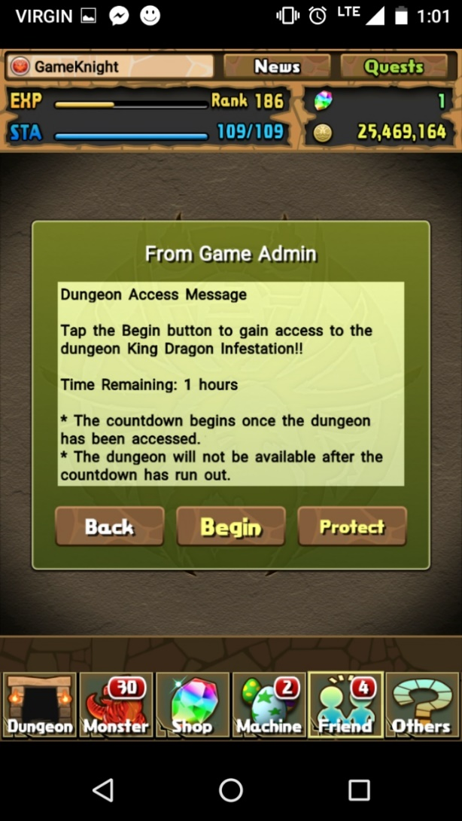

Figure Dungeon Mail

**Dungeon Mail**

This is mail that will give you access to a certain dungeon with a set length of time for availability.

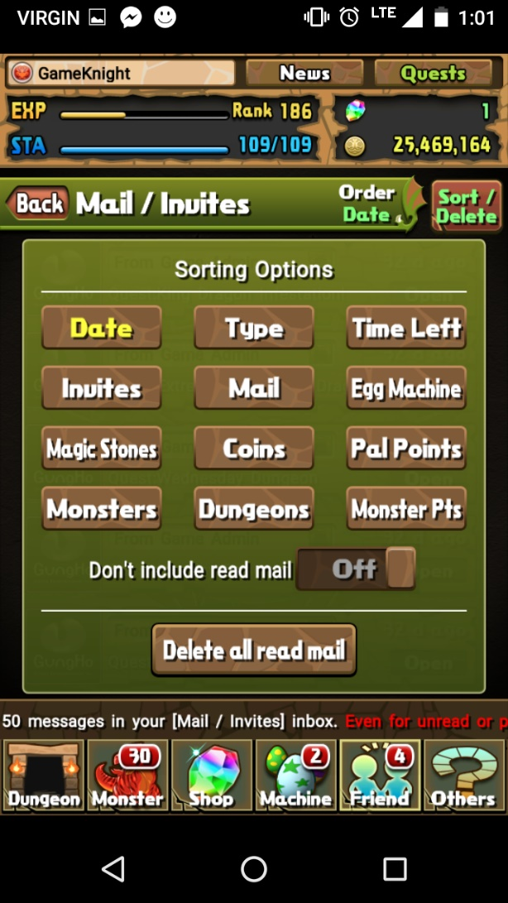

**Mail Sorting / Deleting**

Figure Mail Sorting

These are the various options and ways you can sort mail as well as where you can delete all mail simultaneously with one exception\*

**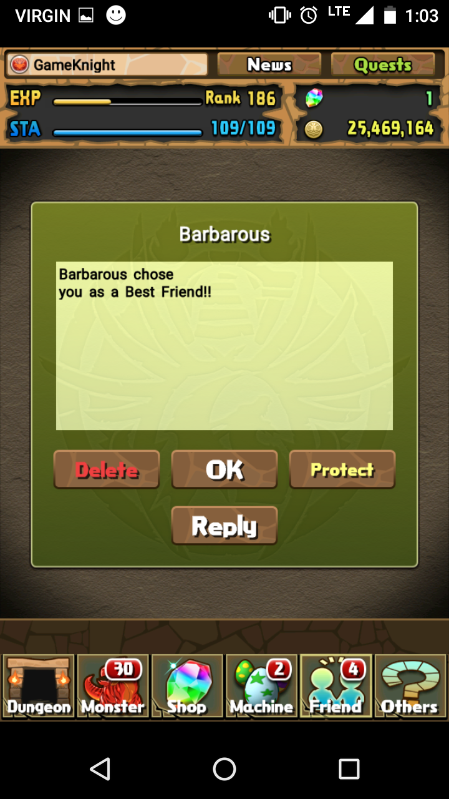Best Friend Mail**

Figure Best Friend

This is a mail message displayed when someone chooses you as a best friend

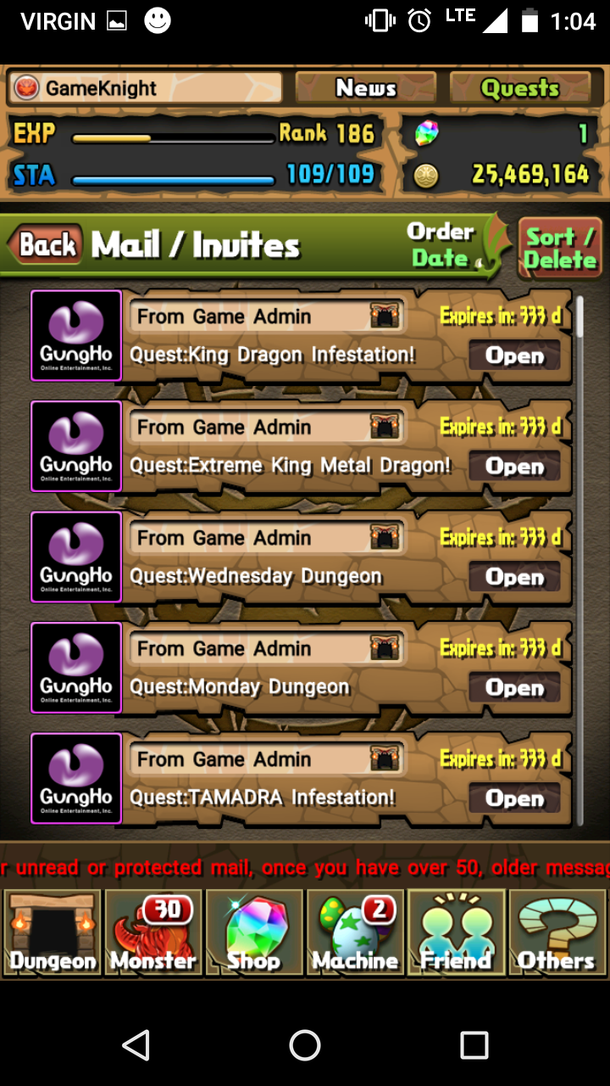

**Mail Expiry**

This displays how many days an unopened piece has before it expires

Figure Mail Expiry

### Friends

Friends are players that have either accept a friend request from you or that you have accepted friend requests from. You can use their leaders as helpers in dungeons to get bonuses.

#### Gaining Friends

* Accepting a friend request
* Sending a friend request to a non-friend helper
* Sending a friend request to a specific player ID

#### Friend Types

* Non-Friends
  + Players not on your Friend List
  + Labeled as User in Select a Helper screen
  + 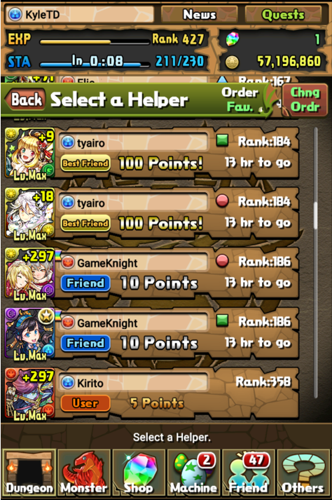Given a chance to send a friend request after successfully completing a dungeon using their leader as a helper

Figure Select a Helper Screen

* + Can only access their current leader
  + Gain 5 Pal points after successfully completing a dungeon using their leader as a helper and vice versa
* Friends
  + Players found in Friend List
  + Labeled as Friend in Select a Helper screen
  + Can access their first and current leader and vice versa
  + Gain 10 Pal points after successfully completing a dungeon using one of their leader as a helper and vice versa
  + Can only use each leader once every time they log in
  + Friend must log in daily for their leaders to be selectable
* Best Friends
  + Listed as best friend in Friend List
  + Labeled as Best Friend in Select a Helper screen
  + Can access their first, second, and current leader and vice versa
  + Gain 100 Pal after successfully completing a dungeon using one of their leader as a helper and vice versa
  + Unlocks a best friend selection at rank 50
  + 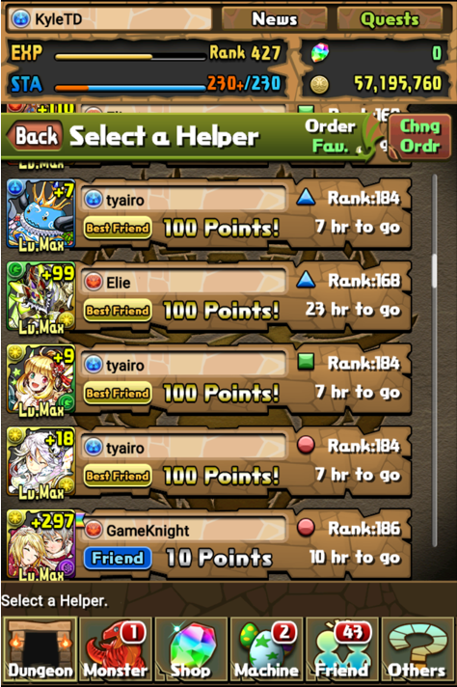Best friend status’ are two ways, meaning if one friend upgrades a friend to a best friend, both player have the best friend status for each other

Figure Team Indication on Helpers

* + Friend must log in daily for their leaders to be selectable
  + Best friend’s leaders are available all day no matter how many times they are used so long as the best friend has logged in within the day

Each of these three symbols correlates to a team. (See Figure 15)

* Circle: Team 1
* Square: Currently selected team
* Triangle: Team 2

#### Friend List

The friend list is used to view all of your current friends with their current team’s leader. Here you can choose to (See Figure 17 & 18):

* 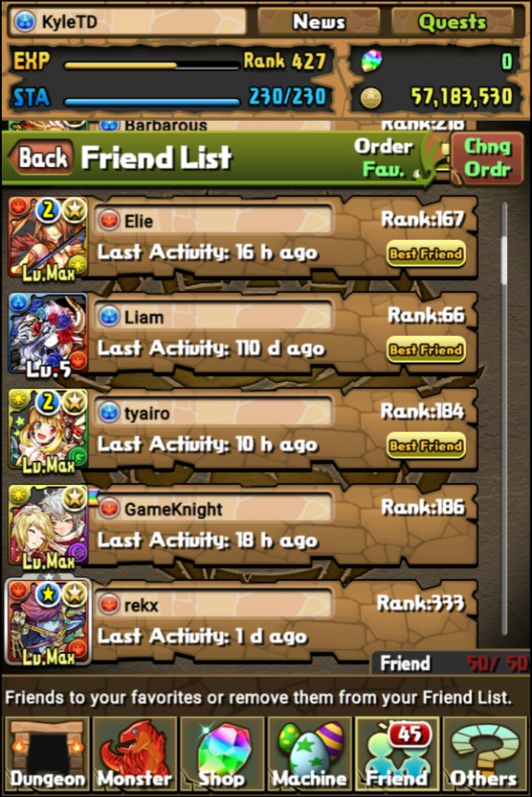Add to Favorite – Gives a friend a favorite status, preventing you from deleting that friend as well as making them easier to find in both the Friend List and Select a Helper screens

Figure Friend List Screen

* Check Info – Displays the information of the friend’s current leader
* Delete – Removes that friend from your friend list, does not appear if friend is favorited
* Remove from Fav. – Removes the favorite status from a friend, allowing you to once again delete them from your Friend List (Only appears if that friend is favorited)

**Note:** If a best friend is either deleted or deletes you, they will no longer have a best friend status if they are re-added. You also will not get back the best friend status to place on another friend.

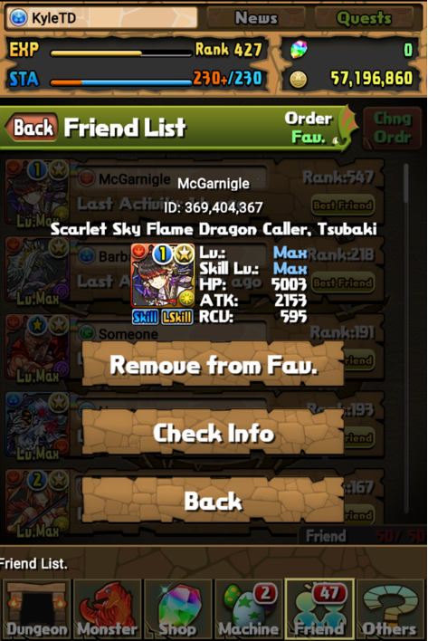Player starts off with 20 friend slots and gains more while ranking up, up to 50 slots.

Figure Friend Options, Favorited

Friend slots can be purchased with magic stones, 1 stone unlocks 5 friend slots.

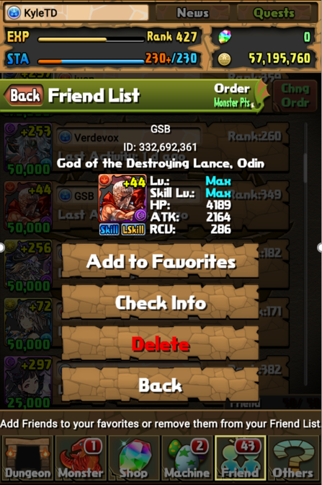

Figure Friend Options, Not Favorited

### Game Currency

Types of Currency

* 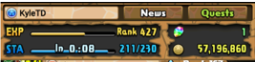Coins (Represented at 57,196,860 in Figure 19)

Figure Coins and Magic Stones

* Pal Points (Represented at 24701 in Figure 21)
* Monster Points (Represented at 157,619 in Figure 20)
* Magic Stones (Represented at 1 in Figure 19)



Figure Monster Points

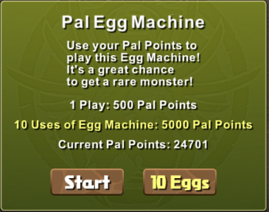

Figure Pal Points

#### Coins

Coins are the most common and most used currency in puzzle and dragons.

Coins are used for:

* Power-Up Fusion
* Evolution
* Assists
* Purchasing Coin Dungeons

##### Ways of Receiving Coins

* Successfully completing dungeons (There are some exceptions)
* Rewards from quests
* Rewards from challenge dungeons
* Selling monsters
* Daily login bonus

#### Pal Points

Pal points are used for the Pal Egg Machine.

##### Ways of Receiving Pal Points

* Choosing a Helper
* Chosen as a Helper
* Completing a dungeon in multiplayer
* Daily login bonus
* Rewards from quests
* Rewards from challenge dungeons

#### Monster Points

Monster points are used to purchase certain monster from the Purchase Monster store.

##### Ways of Receiving Monster Points

* Selling monsters
* Completing dungeons in multiplayer
* Rewards from completing certain dungeons

#### Magic Stones

Magic stones are used for:

* Rare/Event Egg Machines
* Restoring Stamina
* Increasing Monster Box Capacity
* Increasing Friend List Capacity
* Continuing a dungeon you died in

##### Ways of Receiving Magic Stones

* Completing Dungeons
* Purchasing them with real life currency
* Rewards from Admins
* Rewards from quests

## Requirements Fundamentals

## Practical Considerations

## Requirement Information Items

# Processes

## Requirements Processes

## Stakeholder Requirements Definition Process

## Requirements Analysis Process

## Requirements Engineering Activities in Other Technical Process

## Requirements Management

# Information Items

# Guidelines for Information Items

# Information Item Content